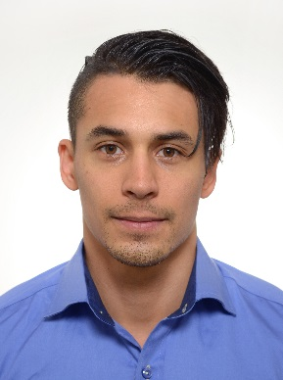Daniel Fellman   |   Curriculum Vitae

Aningaisgatan, Åbo, 3 b 41, 20100  |  +358 50 528 9450  |  daniel.fellman@abo.fi   
linkedin.com/in/daniel-fellman  
researchgate.net/profile/Daniel_Fellman  
https://danielfellman.github.io/

# **PROFESSIONAL SUMMARY**

* Forward-thinking data scientist (PhD in Psychology) with 3 years of scripting in R coupled with proficient skills in conducting complex statistical analyses and a strong understanding of research methodologies.
* Effective and confident science communicator in three different languages (fluent written- and oral skills in Swedish, English, Finnish), with the ability to make complex data understandable for a broad audience using various data visualization techniques.
* **Creative and self-motivated individual with easy-integration in a multicultural environment with unique combination of detail-oriented mindset, driven personality, and proven ability to meet tight deadlines by working in fast-paced work environments.**

# **WORK EXPERIENCE**

**Researcher** | Åbo Akademi University 2015 – 2018

* **Proficient skills in statistical modeling (e.g., regression, classification)**, as evidenced in being assigned the main responsibility for the statistical parts in altogether six research projects.
* **Excellent teamwork and collaboration skills demonstrated by managing several logistically demanding research projects (approximate circulation** 50,000€)**, resulting in five scientific publications, the development of international collaboration, and** €**12,000**€ in grant funding.
* Routinely used R and SPSS for statistical analyses, PowerPoint for scientific presentations, and advanced Excel functions to generate spreadsheets and to prepare datasets for further analyses.
* Responsible for a university-level course titled “Behavioral Science”, covering the basic principles in research methodology and psychometrics.

**Statistical advisor** | Åbo Akademi University 2017 – 2018

* I serve as a statistical advisor for undergraduate students covering consultancies such as choice of analytical approach, execution of analyses, and interpretations of the results.

**Research assistant** | Åbo Akademi University Aug 2014 – Oct 2015

* In collaboration with a data engineer, I built and developed experimental tasks (measuring human memory) on an in-house developed web-based test platform.

# **EDUCATION**

**Åbo Akademi University | Åbo, Finland** 2015 - 2018

Doctor of Philosophy, Psychology, Cognitive Training

**Åbo Akademi University | Åbo, Finland** 2011 – 2015

Masters of Arts, Logopedics

# **SKILLS**

**Data analysis:** regression, multilevel regression, classification, unsupervised learning, ANOVA

**Statistical software:** R (tidyverse, caret, knn, kmeans, rpart, randomForest), SPSS, Excel

**Databases:** SQL (PostgreSQL)

**Data visualization:** R (ggplot2)